
SOUTH EAST EDUCATION DIVISION EXAMINATIONS

2026 MALAWI SCHOOL CERTIFICATE OF EDUCATION MOCK EXAMINATION

PHYSICS
Subject Number: M164/II
Monday, 30 March Time Allowed: 2 hour sessions
10:00 am onwards
PAPER II
(40 marks)
Practical
Instructions:

- This paper contains 7 printed pages. Please check.
Question number | Tick if answered | Do not write in this column
1
2
3
4
- Before beginning, fill in your full name at the top of the question paper.
- Write your answers on the question paper.
- This paper has two sections, A and B.
- Section A contains two descriptive questions on practical work to be answered in 1 hour. Marks will be given for accurate and orderly presentation of facts supported by relevant diagrams.
- In Section B there are two practical questions to be answered in 1 hour.
- You should spend 30 minutes on each question. The 30 minutes period allowed for each question
includes 3 minutes to tidy up the apparatus and have it checked by the supervisor.
8. Marks for section B will be given for observation,
accuracy and interpretation of results.

© 2026 SEED MOCK Turn over

SECTION A (20 Marks)
1. With a well labelled diagram, describe an experiment that can be used to verify Hooke’s
law.

____________________________________________________________________________________________________________________________________________________________________________________________________________________________________________________________________________________________________________________________________________________________________________________________________________________________________________________________________________________________________________________________________________________________________________________________________________________________________________________________________________________________________________________________________________________________________________________________________________________________________________________________________________________________________________________________________________________________________________________________________________________________________________________________________________________________________________________________________________________________________________________________________________________________________________________________________________________________________________________________________________________________________________________________________________________________________________________________
(10 marks)
Continued/…
2. Describe an experiment to show that sound cannot travel in a vacuum.

____________________________________________________________________________________________________________________________________________________________________________________________________________________________________________________________________________________________________________________________________________________________________________________________________________________________________________________________________________________________________________________________________________________________________________________________________________________________________________________________________________________________________________________________________________________________________________________________________________________________________________________________________________________________________________________________________________________________________________________________________________________________________________________________________________________________________________________________________________________________________________________________________________________________________________________________________________________________________________________________________________________________________________________________________________________________________________________________________________________________________________________________________________________________________________________________________________________________________________________________________________________________________________________________________________________________________________________________________________________________________________________________________________________________________________________________________________________________________________________________________________________________________________________________________________________________________________
(10 marks)
Continued/…
SECTION B (20 Marks)
3. You are provided with a spring balance, a measuring cylinder, water, an object labelled
V and a string.
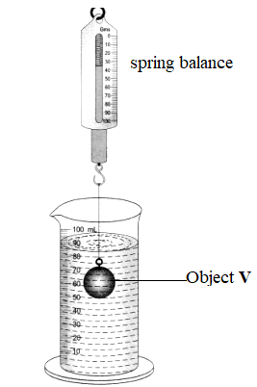
Figure 1
- Tie the object V to the string and measure its weight in air using the spring balance.
- Record its weight in the table of results
- Put water in the measuring cylinder half way and record its volume.
- Slowly place the mass in the measuring cylinder until it is completely immersed as
shown in figure 1
- Record the final volume of water and the weight of object V in water in the table of results.
Table of results
Description | Reading
Weight of object V in air(N)
Weight of object V in water (N)
Initial volume of water (cm³)
Final volume of water (cm³)
(4marks)

Continued/…
- Calculate the upthrust exerted by the water on the object V.

(2 marks)
- Calculate the weight of displaced water, given that the density of water is 1g/cm³. (your answer in 1decimal place)

(4 marks)

4. You are provided with a candle, matches, convex lens, lens holder, meter rule
and white screen.
- Arrange the apparatus as shown in Figure 2 below;
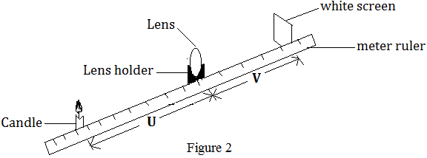
- Light the candle.
- Move the object (candle) until it is 20cm away from the lens.
- Move the screen until a clear image of the object (candle) is formed on the screen.
- Measure the image distance, v and record it in the table of results.
- Repeat steps c to e for object distances, u shown in the table of results below;
- Complete the (u + v) column of the table
Table of Results
Object distance, u (cm) | Image distance, v (cm) | (u + v) (cm)
10
15
20
25
30
40
(4 marks)

Continued/…
- Plot a graph of u + v against u.
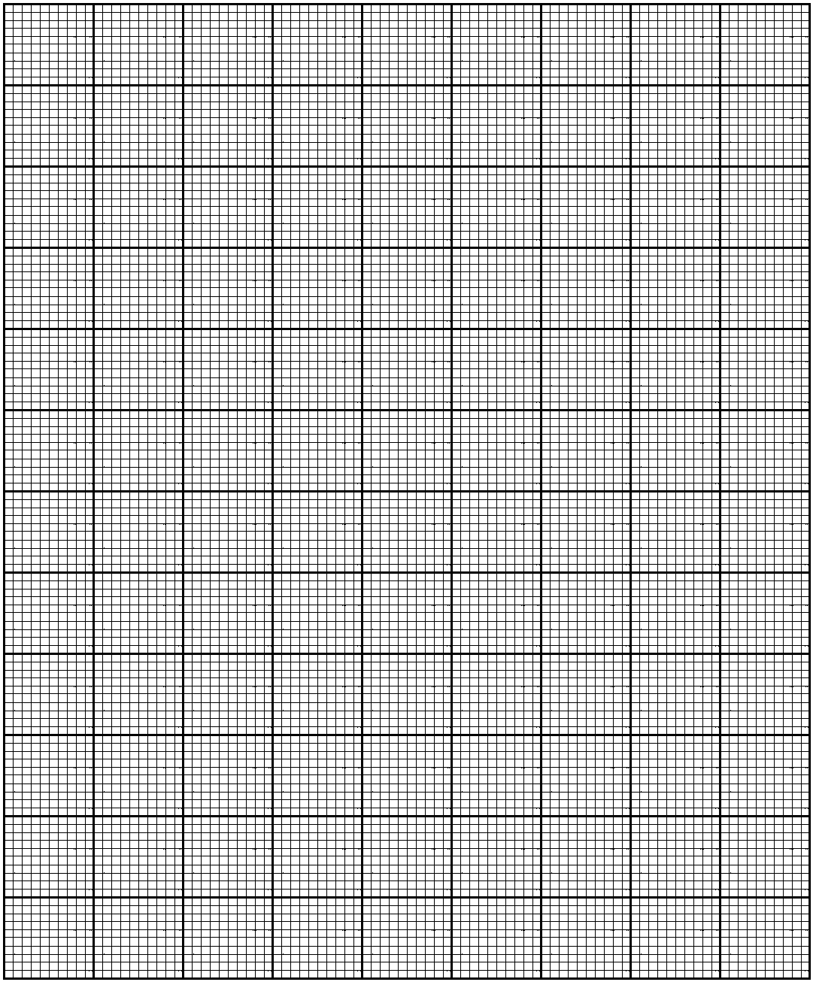
(4 marks)
- Use your graph to determine the focal length of the lens.
_______________________________________________________ (1 mark)
END OF QUESTION PAPER
NB: This paper contains 7 printed pages.

